BIT 4107 – Mobile Application Development
ENHANCED PROFESSIONAL STUDENT LOGBOOK
Student Name: _______TITUS PETER_______________________
Admission Number: _____BIT/2024/73881_________________________
School/Faculty: ___SCHOOL OF COMPUTING AND INFORMATICS___________________________
Programme: _____INFORMATION TECHNOLOGY_________________________
Academic Year: _____3RD YEAR_________________________
Semester: _____2ND SEMESTER_________________________
Lecturer: ______NYORO MICHAEL________________________
Phone Number: ________0715456061______________________

Instructions
This logbook is used to document weekly learning activities, practical exercises, skills acquired, challenges encountered, solutions applied, and reflections. Students should complete all sections every week.
Each week to follow remarks in week 1 section.

Autogenerated Table of content

Week 1: Introduction to Mobile Application Development

Practical Activities Undertaken


Tools/Software Used
-Android Studio

Personal Reflection
I found Android studio simpler to set up and use as compared to other IDEs especially with its built in AI integration to help users

Week 2: Mobile Development Environment
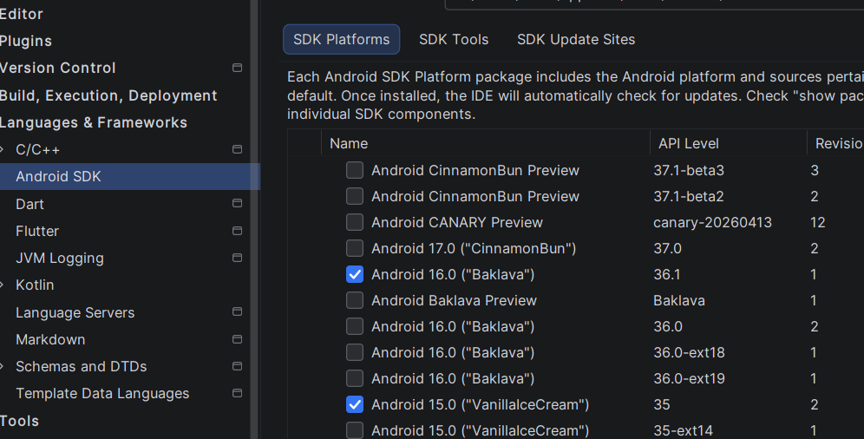
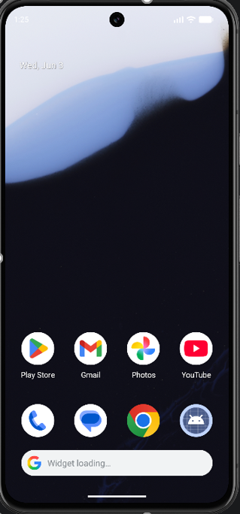
Tools Used:
Android Studio
Personal Reflection
I understood how to set up and use a mobile development environment effectively. Gained experience with android studio and configurations in app development

Week 3: User Interface Design

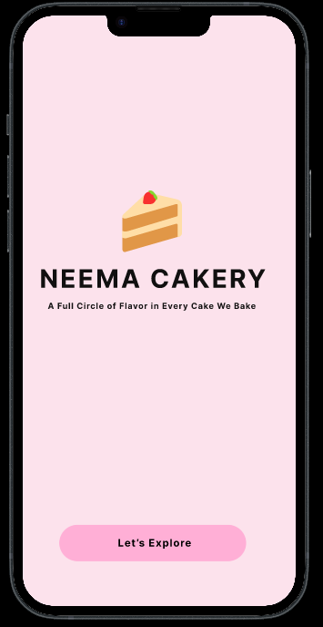
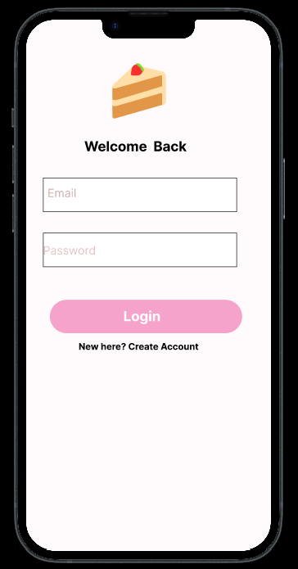
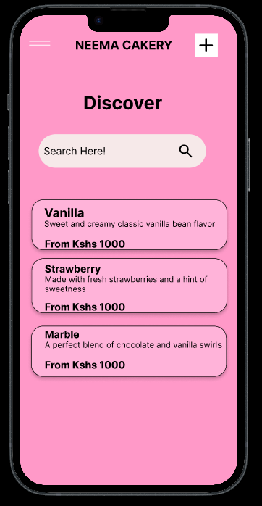
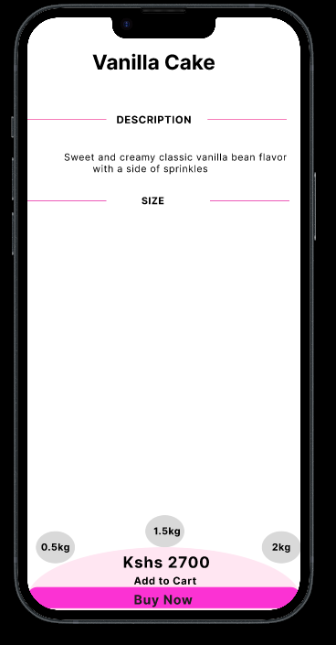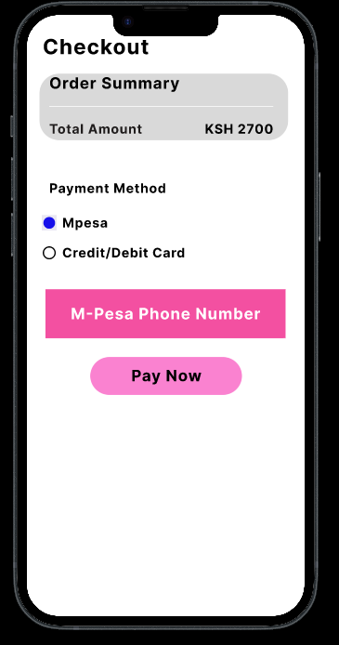
Tools Used:
-Figma
Personal Reflection:
Understood the principles of user interface design using Figma. Got the practical skills in creating visually appealing and user friendly layouts

Week 4: Event Handling and User Interaction

Week 5: Data Management

Same as week 1

Week 6: Networking and APIs

Same as week 1

Week 7: Application Architecture

Same as week 1

Week 8: Project Planning

Week 9: Device Features and Sensors

Same as week 1

Week 10: Notifications and Background Services

Same as week 1

Week 11: Mobile Security

Same as week 1

Week 12: Testing and Debugging

Same as week 1

Week 13: Application Deployment

Same as week 1

Week 14: Final Project Presentation

Same as week 1

Semester Project Tracking

Project Title

Project Objectives

Project Requirements

Development Milestones

Testing Results

Lessons Learned

Future Improvements

End of Semester Reflection

Summary of Skills Acquired

Most Interesting Topic

Major Challenges Faced

How Challenges Were Overcome

Professional Growth Achieved

Overall Course Experience

Final Approval
Student Name: __________________________
Student Signature: ______________________
Date: _________________________________
Lecturer Name: _________________________
Lecturer Remarks: _____________________
Date: _________________________________

